Canvas 7-12 Academic Style Guide – Oxley College

The aim of this style guide is for a consistent user experience for students and parents.

|  |  |  |
| --- | --- | --- |
| Aspect | Minimum Requirements | Best Practice |
| Home Page | * Use [**Pages Front Page**](https://guides.instructure.com/m/4152/l/41445-how-do-i-set-a-front-page-in-a-course) as the home page. * Include what the students are studying (this might be a full scope and sequence or just a list of the topics for the term / year ahead) * Be clear and easy to navigate | * Provide links to the relevant work or common resources * Include an engaging image (without sacrificing clarity of the page) |
| Navigation | The Navigation bar should be as streamlined as possible to help students and parents find the relevant material.   * [Exclude](https://guides.instructure.com/m/4152/l/57079-how-do-i-reorder-and-hide-course-navigation-links) everything else you don’t need. You should definitely exclude Files, Pages, Quizzes, Discussions – all of these can be placed within a Module. * Include: Home, Announcements, Assignments, Modules, Learning Field (if being used), Marks (needed to see feedback) | * Check the clarity of your course site by using [Student View](https://community.canvaslms.com/docs/DOC-13122) |
| Modules | Place all work and content in an appropriate [Module](https://guides.instructure.com/m/4152/l/55575-what-are-modules-for-instructors). If work & content are named well, and in an appropriate place, half the battle for helping students finding what they need is won. Instructions on how to create one can be found [here](https://community.canvaslms.com/docs/DOC-10066). | * Organise modules according to content, not according to timeframe. This helps with sharing content. * Use the [indention](https://guides.instructure.com/m/4152/l/322062-how-do-i-use-the-modules-index-page) and [text header](https://community.canvaslms.com/docs/DOC-9945-415240798) features to help organise your Modules if needed. * Use [Module requirements](https://community.canvaslms.com/docs/DOC-13134) to track student progress |
| Assessment Notifications | * Created as an [assignment](https://guides.instructure.com/m/4152/l/67003-how-do-i-create-an-assignment) in an [Assignment Group](https://guides.instructure.com/m/4152/l/41291-how-do-i-add-assignment-groups-in-my-course) called “Assessment Tasks” * Have a due date so it appears in the student’s calendar. * Name in the form “SUB ASSESSMENT TASK N” in capitals. ‘SUB’ is your subjects two or three letter code (as it appears on the timetable) and ‘N’ is the number of the assessment task. For example, you might have ENG ASSESSMENT TASK 3 for the 3rd English assessment task. | * Include an [Announcement](https://guides.instructure.com/m/4152/l/50731-how-do-i-make-an-announcement-in-a-course) that links to the assignment. This way we can see if a student has viewed the announcement and it gives another layer of communication. * Include past papers or other support materials |
| Announcements |  | Use instead of a class email ([instructions](https://guides.instructure.com/m/4152/l/50731-how-do-i-make-an-announcement-in-my-course)) since *parental observers can see these too*. Good for date specific things – such as a description for cover work or homework. The actual work may be placed in the Module and linked to within the Announcement. |
| Feedback |  | Provide feedback on work by utilising Assignments and Speedgrader. This enables parental observers to get real-time reporting on their child. |

Course Checklist

Have I:

* Created a **Home Page** that is set to *Pages Front Page*when I select *Choose Home Page*?
* Does my **Home Page** include what the students are studying?
* Is my **Home Page** clear and easy to navigate?
* Excluded everything I don’t need, especially *Pages, Files, Discussions* and *Quizzes*, from my **Navigation** menu?
* Have I placed my course content in **Modules**?
* Have I created an [Assignment Group](https://guides.instructure.com/m/4152/l/41291-how-do-i-add-assignment-groups-in-my-course) called *Assessment Tasks*, ready for when I need to share **Assessment Notifications**?
* Published the course (and any Modules the students need to see)?

**How do I…?**

The following goes through the main skills you need to adhere to the Style Guide.

If you can’t find what you need here, try searching the [Canvas Guides](https://community.canvaslms.com/community/answers/guides/) or the [Canvas Community](https://community.canvaslms.com/). If you want to try more of what Canvas can do start with the *Canvas – Ideas and How to’s as Ski Runs*, which can be found on the [Canvas Training front page](https://oxley.instructure.com/courses/20).

**But wait, I can’t see the [*thing*]?**

* Check to see if this icon  is anywhere and click it (this hides / shows the menu)
* Scroll all the way down to the bottom of the page
* Try zooming out (Ctr with – or Cmd with – on a mac) – sometimes the menu’s move to the bottom if you are zoomed in.

**Using the Rich Content Editor**

When editing anything in Canvas you will be using what they call the *Rich Content Editor*. If you want help using it watch [this video](https://community.canvaslms.com/videos/1073)

**Setting and editing the home page**

1. Go to a course that you are teaching.
2. Click on the  button if you are not there already, and then to the right hand side there should be a button 
3. Select  and then hit . If the **Pages Front Page** option is greyed out then you will need to follow these instructions first - <https://guides.instructure.com/m/4152/l/41445-how-do-i-set-a-front-page-in-a-course>
4. To edit what this page looks like click on from the right hand menu, when you are on the home page. For more details see the video guide (link below).

**Changing the Navigation menu and using student view to check**

1. Log on and go to a course you teach. We are going to simplify the left hand menu so that students see only what they need to.
2. Click on the  tab on the left menu, at the bottom.
3. First, we are going to see what the student sees when they look at this course. On the upper right hand side you should see -  - click this and then have a look around the course. When you are done, make sure you click (at the bottom right) this button - 
4. Then go back to and click on the  tab in the middle of the top of the screen. This will bring up the left-menu items available for your course.
5. From here you will see a list of the menu items available. Click and drag the ones you do not want to the area below this text –



If you are unsure, remove everything except for – **Home**, **Modules**, **Assignments**, **Announcements**. You can always add items later.

1. Go back to student view and see how the left hand menu has been tidied up. *Remember* to leave student view after you have finished (bottom right of screen).

**Using & Organising Modules**

1. The best way to organise content in a Canvas course is by sorting them into Modules. To create a module go to  (left menu) and then at the top right click .
2. To add content to a Module, click on the  button that is in the same row as the Module name. You will get a menu of the different options of what you can add. Some more instructions are [here](https://guides.instructure.com/m/4152/l/41427-how-do-i-add-items-to-a-module).
3. It is good to keep these tidy and organised. To help you may need to [reorder items](https://guides.instructure.com/m/4152/l/41425-how-do-i-reorder-modules), [indent some items](https://guides.instructure.com/m/4152/l/322062-how-do-i-use-the-modules-index-page) or check the [Oxley College Canvas Style Guide](https://oxley.instructure.com/courses/20/pages/canvas-style-guide).

**Creating an Assessment Notification**

1. Select the course that your assessment task is for from the **Courses** tab.

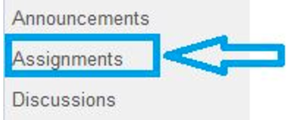2. To find this click the **Assignments** tab at the left of your course page (if you can't see this, look for a and click that first).

3. Then click the blue button that says **+Assignment.**Note - if you do not have an assignment group called "Assessment Tasks" you can create one now by clicking on the **+Group** button.

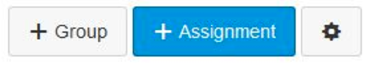

4. Next you will need to enter the name of the Assessment Task into the space where it says **Assignment Name**.

Note that all assessment tasks should be names "SUB ASSESSMENT TASK N", where 'SUB' is the two or three letter abbreviation for your course, and 'N' is the number of the assessment task. This is the only place where uppercase should be used, to help students, parents, learning support and others quickly identify assessment tasks.

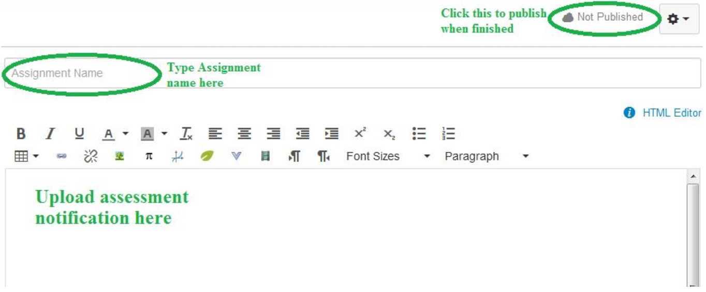

5. Next you need to upload the assessment notification (this is like saving the file to the Canvas course). Click in the space below the assignment name (where it says "Upload assessment notification here" in the screenshot above). Then go to the **Insert Content into the Page** tab to the right of the screen and select **Files (1)**. Click **Upload a new file (2)** and find your document on the computer by clicking **Browse (3)** and then selecting your file. Finally you must click the **Upload (4)** button.

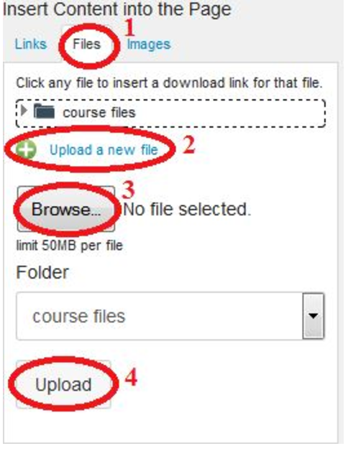

6. Select the Assignment Group - this should be **Assessment Tasks**. If you haven't created this group yet you can [create it later](https://guides.instructure.com/m/4152/l/41291-how-do-i-add-assignment-groups-in-my-course)and then edit this assignment.

7. Set the assessment date. This option is further down the screen under **Due Date**.



8. Select the type of submission. For most tasks this will be "No Submission" - which just means that the task is being done in class, or handed in hard copy. If you want to have an "online submission" it is worth restricting the file types to make it easier for yourself - more information can be found here - <https://guides.instructure.com/m/4152/l/41295-how-do-i-restrict-online-submission-file-types-for-an-assignment-in-my-course>. For submitted online work use PDF as the file type unless you need audio or video.

 9. Click **Update Assignment** at the bottom of the page. This will take you back to the assignments page

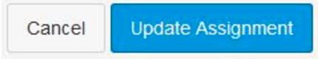

10. Click **Publish** (changing the  to a ) - otherwise your hard work will be hidden from the students!

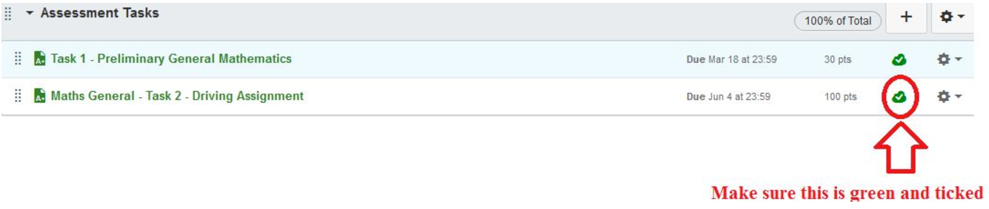

11. Let students know that there is an assessment notification by creating an [Announcement](https://guides.instructure.com/m/4152/l/50731-how-do-i-make-an-announcement-in-a-course)to let them know. You should insert a link to the Notification of Assessment by choosing the link menu on the right hand side of the page when you are writing your announcement, and finding the relevant Assignment.